**WELCOME TO SPRING**

When we decide to get out into the garden and get our bodies lovely and warm again.

BRISBANE**,** City of Queensland, was called MEANJIN by the traditional owners, the TURRBAL people, one of two local first nation groups – the other being the JAGERA people. Meanjin means shaped like a “spike”.

Brisbane was originally called “EDENGLASSIE” in honour of Thomas Makdougall BRISBANE, Governor of New South Wales (1821-1825) when the convict settlement was declared a town in 1834.

The oldest part of the Brisbane CBD is the original penal settlement which was at the North Quay in 1825. Explorer, John Oxley, named the river after Scotsman, Sir Thomas Brisbane, then the Governor of New South Wales. One of the oldest suburbs in Brisbane is Kangaroo Point, with the first house being build there in 1844.

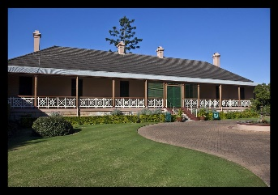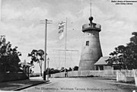The first building, *The Old Windmill,* on Wickham Terrace was built in the 1820’s by convict labour in the Moreton Bay Settlement and is the oldest building in Queensland. The oldest house from that time was “Newstead House”, constructed in 1846, for Patrick Leslie. Newstead House is still open for people to visit and enjoy how beautiful the house is and to walk around the grounds and pretend you live there today.

PADDINGTON is believed to be named after Paddington in London. The area was originally referred to “as being behind the jail”, a reference to the Brisbane Main Jail located close by on Petrie Terrace. The area was settled in the 1860’s. In 1861 the land between Brisbane City and the Jail was auctioned off, with the best sites for housing and commerce on the elevated ridge which soon became, Petrie Terrace.

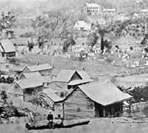The first burial ground was in Skew Street near North Quay and in the 1820’s was used for soldiers and convicts. The first Public Morgue was in the grounds of the former Convict Hospital at North Quay in today’s George Street between Adelaide and Ann Streets. The Paddington Cemetery operated from 1844 to 1875 (photo on left). Another cemetery was established at Nundah by a German Missionary in 1838, as part of the Moreton Bay Settlement and is possibly the oldest in Brisbane.

The Paddington Cemetery operated from 1844 to 1875 (The North Brisbane Cemetery) and in 1875 the area was so heavily populated that the Paddington Cemetery Act 1911 was introduced and the site was redeveloped as a recreational area, with the interred transferred to the Toowong Cemetery. Around 1862, the Anglican Church established a Mortuary Chapel for the Old Cemetery which had been demolished in 1891. The Cemetery was flooded during the 1893 Brisbane floods. In the early days the park was diverse in its sporting use, including Cycling, Athletics and Soccer. In 1914 the former Anglican, Presbyterian, Roman Catholic and Jewish Burial Grounds were gazzetted as LANG PARK and named after The Reverend John Dunmore Lang, who was instrumental in bringing migrants directly to Brisbane in 1849. During World War I the area was also used as a parade ground.

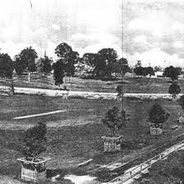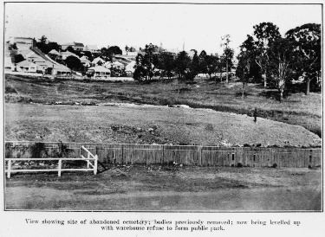LANG PARK – The Rugby League Football Ground saw the inaugural State of Origin on the 8th July, 1980, which was not the first of the start of a series, but a one-off between two sides. The scores were Queensland 20 and NSW 10. Someone then suggested that they start a series of State of Origin, where one team would have to win two out of three games played, to win the series for that year. One of the series was won by Queensland with 52 points to NSW 6 points. That 46 point lead remains unbeaten throughout the series up until now. The name of Lang Park was changed from “The Cauldron” to the Brisbane Stadium” for the duration of the FIFA Tournament, as all International Tournaments like FIFA require corporations to be removed from the Host Stadiums.

Mens Rugby League and other sporting teams now share the limelight with the Ladies sporting teams and it seems that although this has been a long time in coming, everybody likes to see the ladies prove just how good they are.

**GO GIRLS GO QUEENSLAND**

**THANK YOU FROM ASHGROVE MEALS ON WHEELS**

**ACKNOWLEDGEMENT FOR DONATIONS FROM 31 MAY TO 31 AUGUST 2023**

05.06.2023 Client $50.00 donation

09.06.2023 Client $50.00 Donation

09.06.2023 Ashgrove/The Gap Lions Club $1,019.00 for back gate, hand rail, steps and repair of fence.

19.06.2023 Client $50.00 Donation

20.06.2023 Client $50.00 Donation

20.06.2023 Client $1,000.00 Donation

21.06.2023 Client $220.00 Donation for client’s in need.

21.06.2023 Woolworths, Paddington $50.00 gift card to purchase insulated bags.

29.06.2023 Coles, Ashgrove $100.00 gift card for Bunnings BBQ 15.7.2023

30.06.2023 Delivery Driver 6 bottles of honey.

07.07.2023 Officeworks, Windsor 6 x folders, laminating pouches and 10 receipt books.

10.07.2023 Client $50 Donation

14.07.2023 Friend of a Client $10.00 Donation

17.07.2023 Bunnings BBQ $54.50

**Note from the Office regarding meals deliveries**

Ashgrove Meals on Wheels will be closed for the King’s Birthday on Monday 2nd October 2023. We will deliver Monday’s meal on Thursday 28th September instead.

If you do not wish to have a meal for this day, then please let the Office know on 3366 4299.

Delivery volunteers will also be checking if you would like a meal closer to the date.

 **DATES TO REMEMBER**

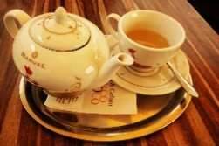**FATHERS’DAY SUNDAY, 3RD SEPTEMBER, 2023**

We wish all Fathers, Grandfathers,Uncles a Very Happy Fathers Day even though it is a belated one.

**SCHOOL HOLIDAYS**

FRIDAY, 15TH SEPTEMBER TO TUESDAY, 3RD OCTOBER, 2023

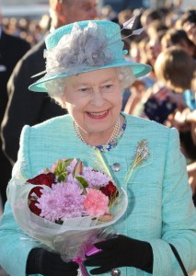12 MONTHS AGO **– 8TH SEPTEMBER, 2022 – QUEEN ELIZABETH II** **PASSED AWAY** IN ENGLAND. THE QUEEN WAS AN INSPIRATION TO ALL AND WELL LOVED BY ALL, AND HER ELDEST SON, CHARLES SUCCEEDED HER ON THE THRONE IN MAY 2023.

**MONDAY, 2ND OCTOBER, 2023**

Ashgrove Meals on Wheels will be closed for the **King Charles III Birthday** on Monday 2nd October 2023. See notice regarding delivery of your meal above.



**SATURDAY,11THNOVEMBER,2023**

**REMEMBERANCE DAY**

Breakfast eat like a King”, “Lunch eat like a Prince”, and “Dinner eat like a Pauper”? Well, we don’t have to eat like the above, but we should eat something nutritious for breakfast, which is why we at AMoW have the solution for you. We have a ‘breakfast bundle’ already packed and ready to be delivered with your meal on your delivery day. In your Breakfast Bundle, you will receive --½ loaf of bread, 1 ltr of milk, 1 ltr of juice, 3 containers of a variety of tinned fruit and 7 packets of various types of cereal. If you would like to start receiving the Breakfast Pack with your next meal delivery.

PLEASE CALL THE OFFICE ON 33664299. 

**CAN YOU FIGURE OUT WHAT PART OF THE HUMAN BODY EACH CLUE** **REPRESENTS? GOOD LUCK.**

1. Tug boats do it
2. Miniature general
3. Joins wood together
4. Loser to the tortoise
5. Two students
6. Prepare for war
7. Place of Worship
8. A number of negatives
9. To do with the sea
10. A part of a river
11. Humourous calcium callus
12. Trendy
13. The top master
14. Edge of a bowl
15. Porcupines have more than one
16. Add a “P” to a great singers name
17. Character in mid-summer nights dream
18. Pumping station
19. A marionette pig

20.Bearer of coconuts ***Answers on back page***

**SCAMS** are on the go again, including advising you that your Medicare Card out of date – don’t be fooled, this is not correct so don’t be mislead and give out your personal information. Your own personal bank likewise, does not ask for your personal details and passwords.

***IT’S THAT TIME AGAIN***

Did you hear about the 83 year old man who was being yelled at by a young woman in the car behind him at the “place your order here” section of KFC, because he was taking too long to place his order. He told the young man behind the first screen to tell her that he would pay her order for her, to which she mouthed her reply“Thank You” and smiled. Off he goes to the next window to collect the two meals and tells the young girl behind the screen what is going on and that he will take both meals himself. Once he has the meals in his car, he drives off leaving the woman in the car behind frothing and fuming because she has to line up again AND pay for her meal when she gets to the front again. The old man drives off smiling and thinking “that will teach her to be more polite to old people in future”. The moral of the story is “DON’T MESS WITH THE OLDIES”!!!!

NEVER FALL IN LOVE WITH A TENNIS PLAYER. Love means nothing to them.

Where does a rottweiller sit at the movies? Anywhere it wants to.

Computers can never completely replace humans. They may become capable of artificial intelligence, but they will never master real stupidity.

By all means go ahead and mellow with age. Just be wary of getting rotten.

‘Doctor, you’ve got to help me; I can’t stop thinking I’m a goat.”

*“I see. Just how long have you had this problem?”*

“Ever since I was a kid”.

One day the bass player hid one of the drummer’s sticks.

*The drummer said, “Finally! After all these years, I’m a conductor!”*

Teacher: “What’s the difference between ignorance and apathy?”

*Student: “I don’t know and I don’t care”.*

Two black bears are walking down the aisle of the grocery store. One turns to the other and says,

“Quiet in here today, isn’t it?”

A computer programmeer is someone who solves a problem you didn’t know you had in a way you don’t understand.

SUDUKO NUMBER 1 SUDUKO NO 2

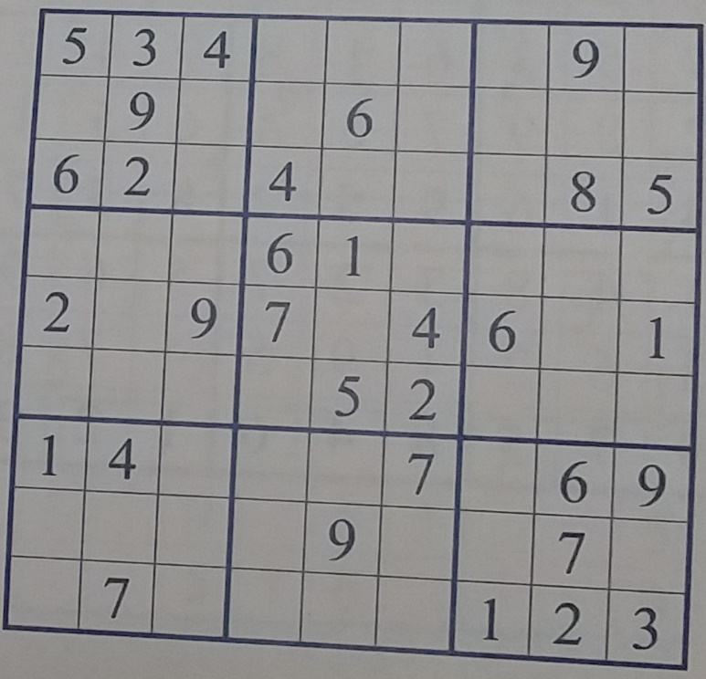 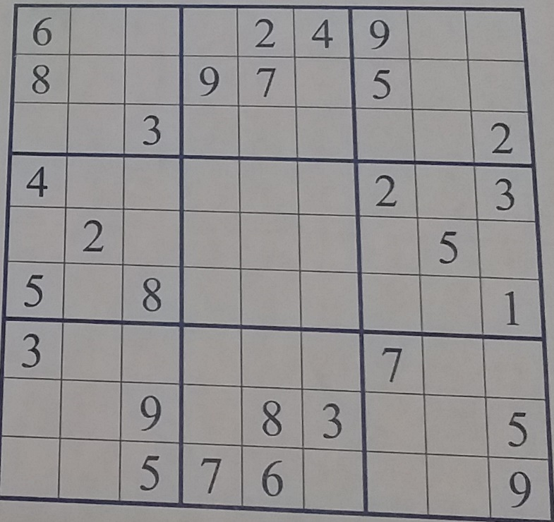

***WONDERS OF NATURE***:

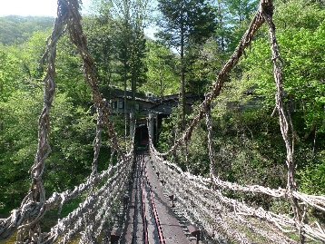**NATURAL ARCHITECTURE** Strong bridges don’t necessarily have to be built from steel and cement. For that matter, they don’t even have to be constructed by man. In northeastern India, amazingly strong bridges are grown using the roots of rubber trees. The rubber tree roots are guided to the other side of the river using hollowed out betel tree trunks. Once there the roots start growing in the soil. After about 10 to 15 years, a functional bridge is formed. Another type of natural bridge is found in Japan’s Ilya Valley. There, bridges are made from growing and weaving long lengths of the exceptionally strong Visteria vine. Some of these vine bridges are thought to have started growing in the 12th century.

(photo above is not the bridge in the article).

**LARGE LOBSTER**..Goliath is the name of a giant lobster, which had fate not intervened, might have ended up on someone’s dinner plate. Weighing in at 7 kg. Goliath was obviously waiting in a Canadian grocery store in Boucherville, Quebec for a customer to purchase him. However, the store manager had received numerous emails, some from other countries, requesting that the laarge crustacean be saved. So Goliath was donated to the Montreal Biodome, a nature museum in Quebec Canada that has replicas of several ecosystems on display.

**HIGH FLYING SNAKE..**Pythons are usually found in their natural habitat or perhaps in a zoo. Passengers however on a flight from Australia to Papua New Guinea got the surprise of their lives when a scrub python(Australia’s longest species of snake) was found on their plane (no not Qantas). The 3m long snake was actually on the wing of the aeroplane when a passenger noticed it when looking out the window when the plane was about 20 minutes into the flight. The reptile had to fight freezing cold and harsh wind, unfortunately did not survive its up in the air ordeal.

**JUST BEFORE WE GO…**

**HOUSE FIRES AND BUSH FIRES** We have all heard aboutthe local fires and house fires lately and the people hurt by these occurances, but in some cases they could possibly have been prevented. We know that we shouldn’t have candles lit and placed by curtains, nor where children can come in contact with candles, matches, lighters.The sad truth is kids don’t understand what the consecquences can be, so we have to make sure we put things out of their reach. I know, we all do our best looking out for the little ones, but we have to make sure we do it. Bush fires can be caused by lightning strikes and in the hot weather they are predicting for this summer, we have to be on our guard. Don’t forget your FIRE EMERGENCY BOX (with a torch, radio, water (including some for pets), mobile phone (if you have one) with emergency telephone numbers). If you are in an area where there are bush fires, or if your house is close to trees etc, they could save your life, or that of someone you love. Check that your neighbours are okay and not in danger, also to let them know what your situation is.

***LAST WORDS***

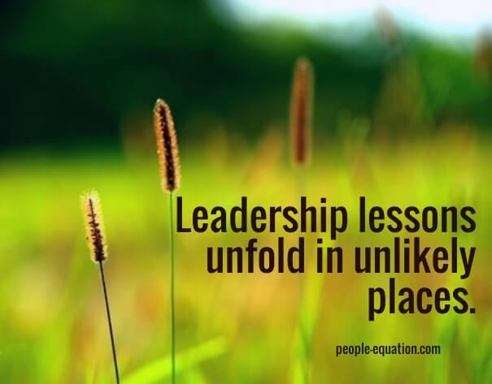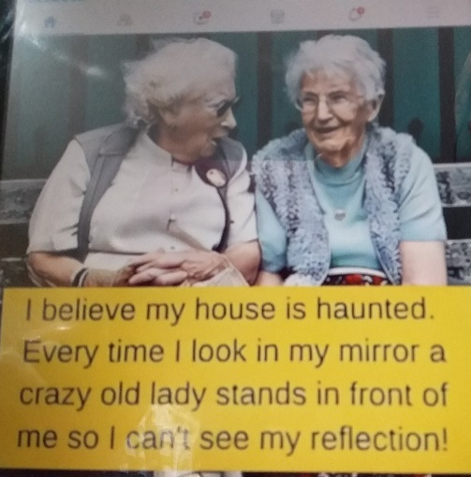 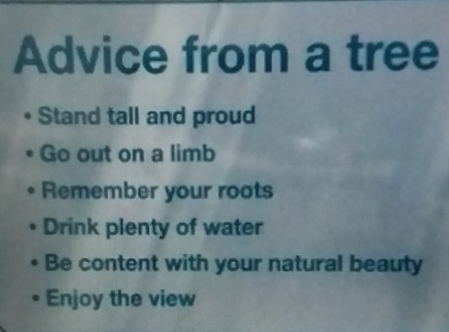

**Val**  **Editor**

**ASHGROVE MEALS ON WHEELS**

**MORE THAN JUST A MEAL**

**DELIVERING TO ASHGROVE AND ADJACENT AREAS**

**As our part of community caring we aim: To provide a wholesome and appealing meal,**

**To be delivered in a friendly, understanding way.**

**Ashgrove Meals on Wheels, 524 Waterworks Road, Ashgrove.**

**All enquiries - Please telephone 3366 4299**

**Email – admin@ashgrovemealsonwheels.org.au**

***This newsletter has been printed with courtesy of Jonty Bush MP, Cooper Electoral Office, Ashgrove.***

***DISCLAIMER – Reasonable efforts have been made to ensure the accuracy of the content of this newsletter at the time of preparation.***

***Opinions expressed in this Newsletter are those of the Editor and not necessarily those of the AMOW***

***team.***

Answers to PARTS OF THE BODY

1. Toe 11. Mouth

2. Thumb 12. Naval

3. Nails 13. Funny Bone

4. Hair 14. Hip

5. Pupils 15. Spine

6. Arm 16. Pelvis

7. Temple 17. Bottom

8. Chest 18. Heart

9. Feet 19. Hamstring

10. Nose 20. Palm

Answers to Suduko

Suduko No. 1 Suduko No. 2

